**CHR Regional Office 2 *(Left & Right Wing Extension)***

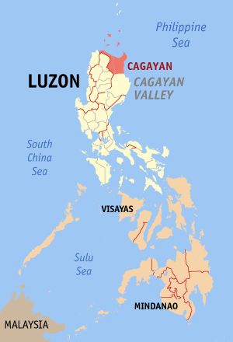Address : *#5 Pappabalo St., Regional Government Center*

*Carig Sur, Tuguegarao City*

*Cagayan*

Lot Area : *1,815.00 sq.m.*

Floor Area : *120.00 sq.m (Left & Right Wing Extension)*

Amount : *Php6,958,121.62*

Date Started : *June 17,2015*

Date Completed : *November 30, 2015*

*Date Inaugurated* : *February 1, 2016*

***CHR Region 2 Office NOW:***

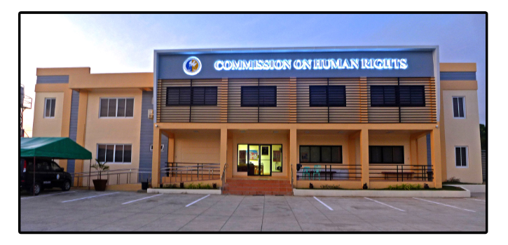

***Inauguration:***

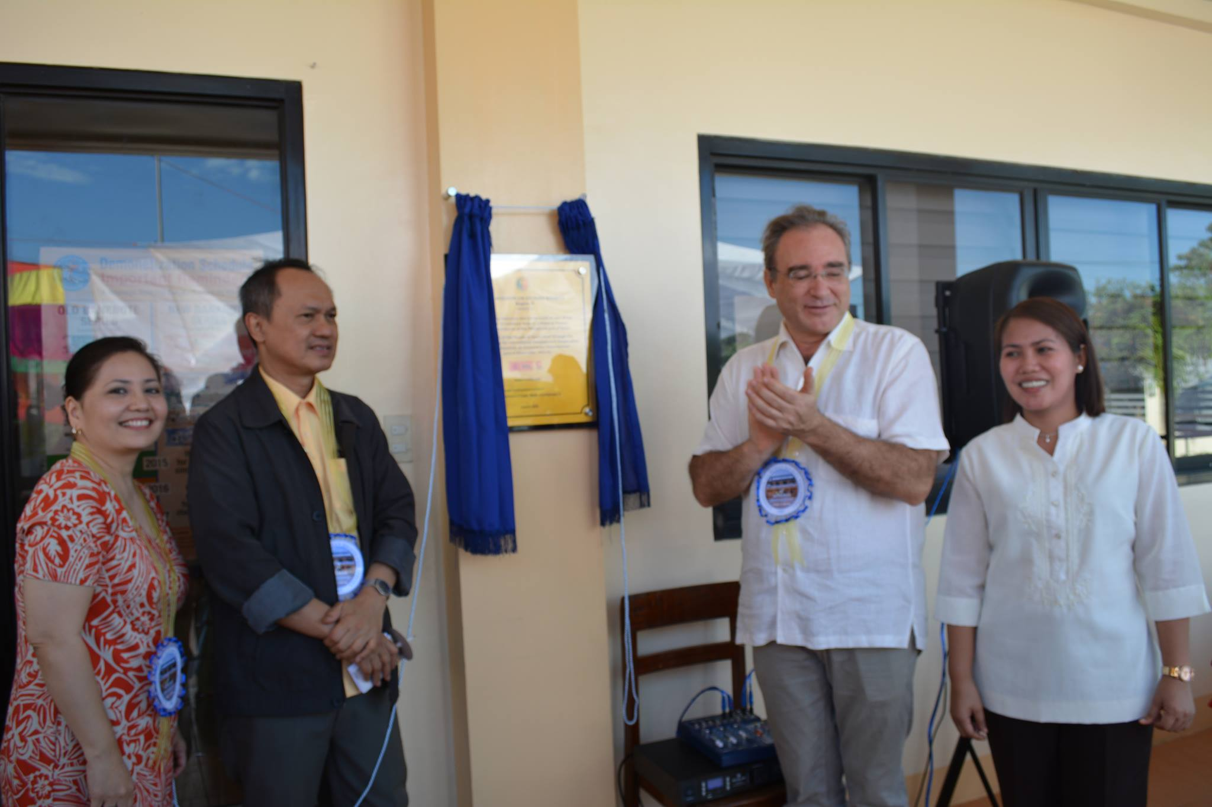

***MOA*** *(CHR & DPWH Region 2 re: Construction)****Signing Ceremony:***

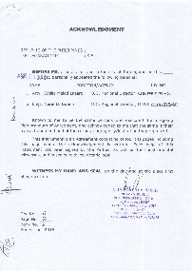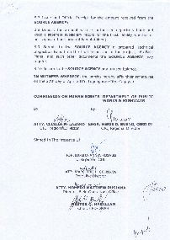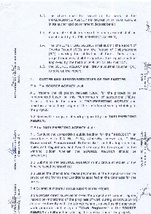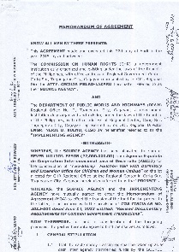

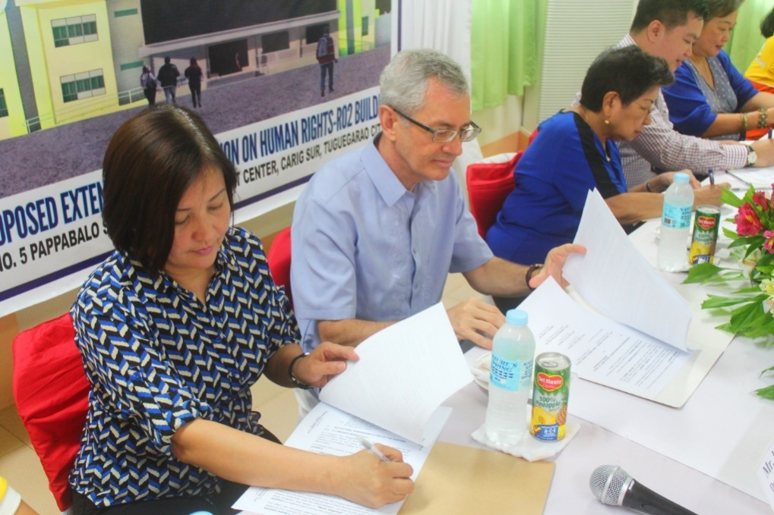

***Groundbreaking Ceremony:***

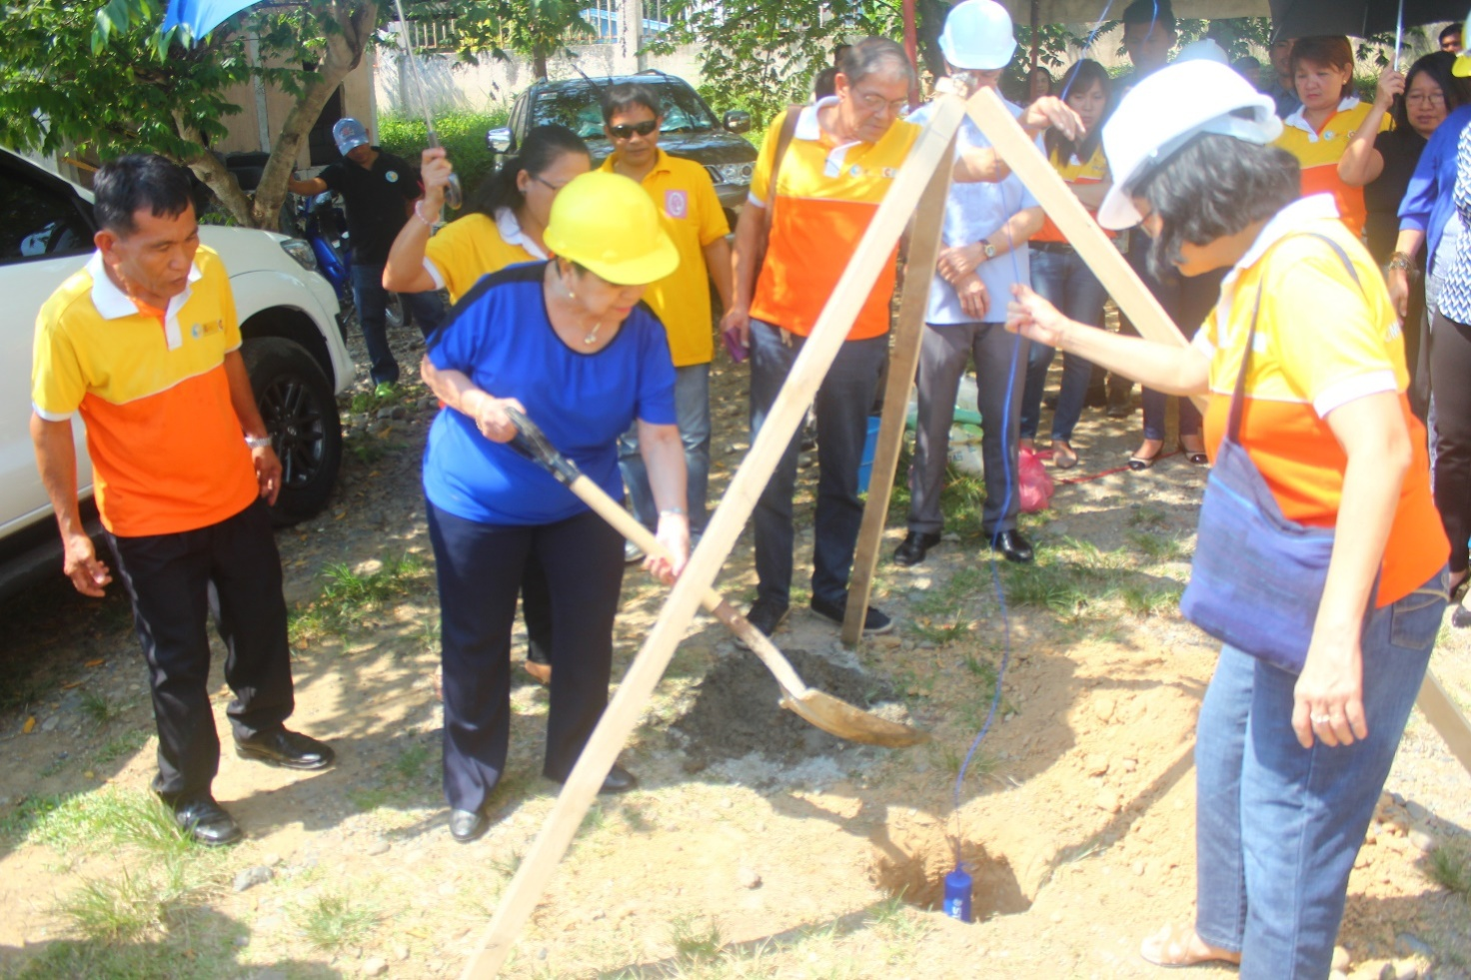

***CHR Region 2 Office BEFORE:***

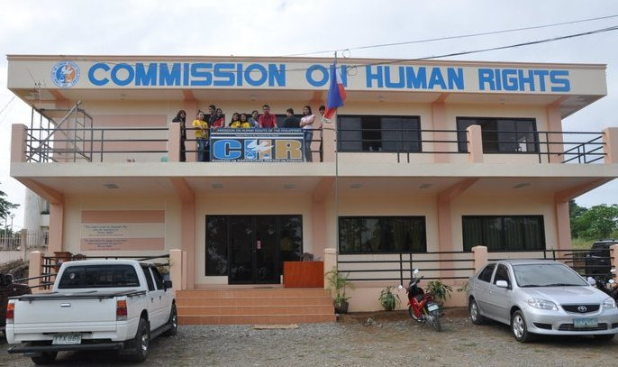

***Land Title:***

[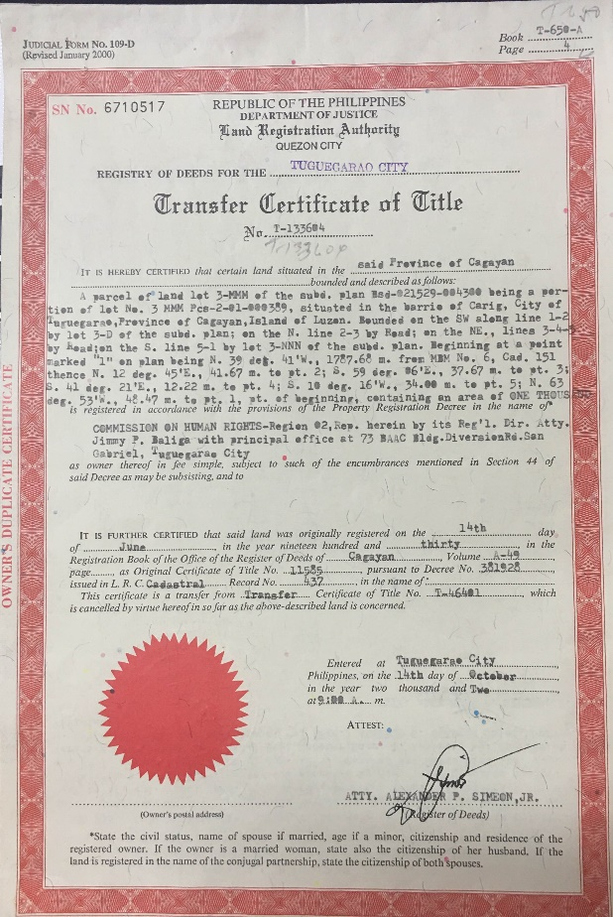](Land%20Title.docx)